Aḥmad Fāris al-Shidyāq (ca. 1805-1887)

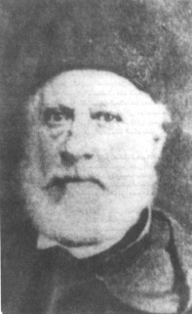

<http://littlestarjournal.com/blog/2014/06/ahmad-faris-al-shidyaq-in-praise-of-analepsis/>

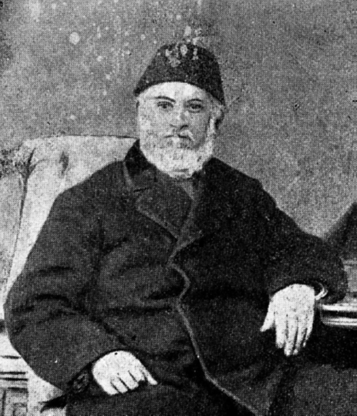

alternative picture of Shidyaq (from a book from 1950)

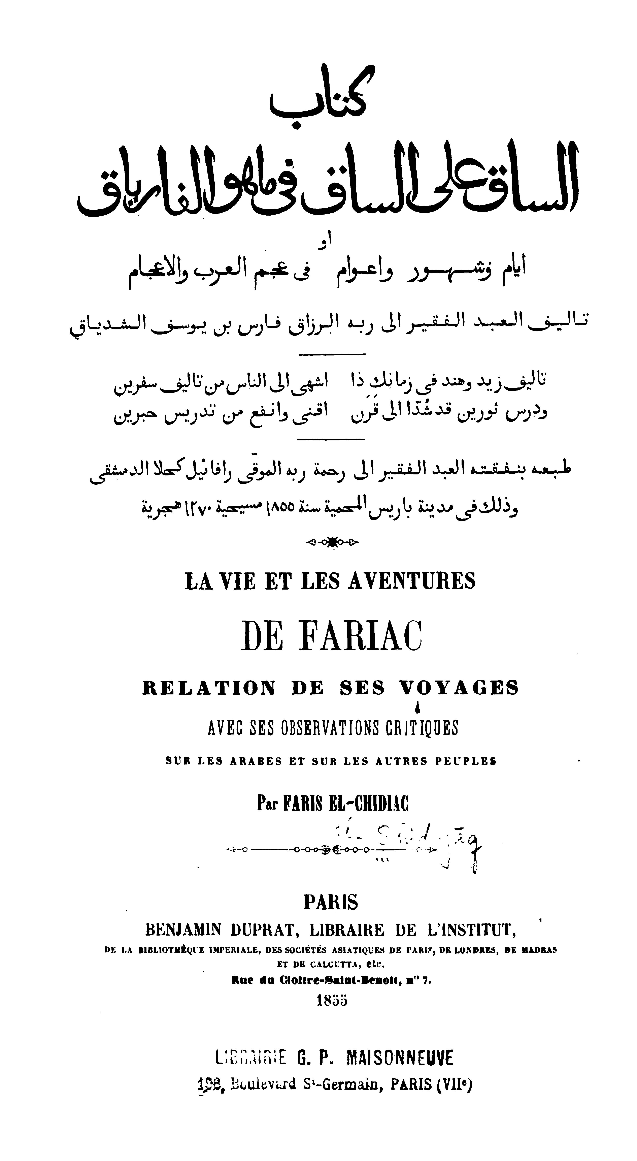

The Arabic-French title page of *al-Sāq ʿalā l-sāq fī mā huwa l-Fāryāq*, published 1855 in Paris. (source: C.J.)

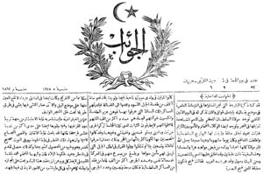

<http://www.marefa.org/index.php/%D8%A3%D8%AD%D9%85%D8%AF_%D9%81%D8%A7%D8%B1%D8%B3_%D8%A7%D9%84%D8%B4%D8%AF%D9%8A%D8%A7%D9%82>

Extract from the newspaper *al-Jawāʾib*